IMS ENGINEERING COLLEGE



LABORATORY MANUAL

Web Designing Lab

(BCS-353)

B.TECH – II YEAR
(ODD SEM 2025-2026)

Name
Roll No.
Section-Batch

DEPARTMENT OF COMPUTER SCIENCE & ENGINEERING
IMS ENGINEERING COLLEGE

(Affiliated to Dr A P J Abdul Kalam Technical University, Lucknow )
Approved by AICTE - Accredited by NAAC – ‘A’ Grade NH#24, Adhyatmik Nagar, Ghaziabad, UP, India
www.imsec.ac.in

Vision and Mission of the Institute and Department

Vision of the Institute
To make IMSEC an Institution of Excellence for empowering students through technical education, incorporating human values, and developing engineering acumen for innovations and leadership skills to upgrade society.
Mission of the Institute
Mission 1: To promote academic excellence by continuous learning in core and emerging Engineering domains using innovative teaching and learning methodologies.
Mission 2: To inculcate values and ethics among the learners.
Mission 3: To promote industry interactions and cultivate young minds for entrepreneurship.
Mission 4: To create a conducive learning ecosystem and research environment on a perpetual basis to develop students as technology leaders and entrepreneurs who can address tomorrow’s societal needs.
Vision of the Department
To provide globally competent professionals in the field of Computer Science & Engineering embedded with sound technical knowledge, aptitude for research and innovation, and nurture future leaders with ethical values to cater to the industrial & societal needs.
Mission of the Department
Mission 1: To provide quality education in both the theoretical and applied foundations of Computer Science & Engineering.
Mission 2: Conduct research in Computer Science & Engineering resulting in innovations thereby nurturing entrepreneurial thinking.
Mission 3: To inculcate team building skills and promote life-long learning with high societal and ethical values.

DEPARTMENT OF COMPUTER SCIENCE & ENGINEERING

PROGRAMME EDUCATIONAL OBJECTIVES (PEOs)

B. Tech Computer Science & Engineering Department has the following Program Educational Objectives:

PEO1: Possess core theoretical and practical knowledge in Computer Science and Engineering for successful career development in industry, pursuing higher studies or entrepreneurship.
PEO2: Ability to imbibe lifelong learning for global challenges to impact society and environment.
PEO3: To demonstrate work productivity with leadership and managerial skills having ethics and human value in progressive career path.
PEO4: To exhibit communication skill and collaborative skill plan and participate in multidisciplinary fields of Computer Science & Engineering.

PROGRAMME SPECIFIC OUTCOME (PSOs)

B.Tech Computer Science & Engineering Department has the following Program Specific Outcomes:

PSO1: To analyze and demonstrate, the recent engineering practices, ethical values and strategies in real time world problems to meet the challenges for the future.

PSO2: To develop adaptive computing system using computational intelligence strategies and algorithmic design to address diverse challenges in data analysis and machine learning.

PROGRAM OUTCOMES

Engineering Graduates will be able to:

- Engineering knowledge: Apply the knowledge of mathematics, science, engineering fundamentals, and an engineering specialization to the solution of complex engineering problems.
- Problem analysis: Identify, formulate, review research literature, and analyze complex engineering problems reaching substantiated conclusions using first principles of mathematics, natural sciences, and engineering sciences.
- Design/development of solutions: Design solutions for complex engineering problems and design system components or processes that meet the specified needs with appropriate consideration for the public health and safety, and the cultural, societal, and environmental considerations.
- Conduct investigations of complex problems: Use research-based knowledge and research methods including design of experiments, analysis and interpretation of data, and synthesis of the information to provide valid conclusions.
- Modern tool usage: Create, select, and apply appropriate techniques, resources, and modern engineering and IT tools including prediction and modelling to complex engineering activities with an understanding of the limitations.
- The engineer and society: Apply reasoning informed by the contextual knowledge to assess societal, health, safety, legal and cultural issues and the consequent responsibilities relevant to the professional engineering practice.
- Environment and sustainability: Understand the impact of the professional engineering solutions in societal and environmental contexts, and demonstrate the knowledge of, and need for sustainable development.
- Ethics: Apply ethical principles and commit to professional ethics and responsibilities and norms of the engineering practice.
- Individual and team work: Function effectively as an individual, and as a member or leader in diverse teams, and in multidisciplinary settings.
- Communication: Communicate effectively on complex engineering activities with the engineering community and with society at large, such as, being able to comprehend and write effective reports and design documentation, make effective presentations, and give and receive clear instructions.
- Project management and finance: Demonstrate knowledge and understanding of the engineering and management principles and apply these to one’s own work, as a member and leader in a team, to manage projects and in multidisciplinary environments.
- Life-long learning: Recognize the need for, and have the preparation and ability to engage in independent and life-long learning in the broadest context of technological change.

GENERAL LABORATORY INSTRUCTIONS

- Students are advised to come to the laboratory at least 5 minutes before (to the starting time), those who come after 5 minutes will not be allowed into the lab.
- Plan your task properly much before to the commencement, come prepared to the lab with the synopsis / program / experiment details.
- Student should enter into the laboratory with:

  - Laboratory observation notes with all the details (Problem statement, Aim, Algorithm, Procedure, Program, Expected Output, etc.,) filled in for the lab session.
  - Laboratory Record updated up to the last session experiments and other utensils (if any) needed in the lab.
  - Proper Dress code and Identity card.
- Sign in the laboratory login register, write the TIME-IN, and occupy the computer system allotted to you by the faculty.
- Execute your task in the laboratory, and record the results / output in the lab observation note book, and get certified by the concerned faculty.
- All the students should be polite and cooperative with the laboratory staff, must maintain the discipline and decency in the laboratory.
- Computer labs are established with sophisticated and high end branded systems, which should be utilized properly.
- Students / Faculty must keep their mobile phones in SWITCHED OFF mode during the lab sessions. Misuse of the equipment, misbehaviors with the staff and systems etc., will attract severe punishment.
- Students must take the permission of the faculty in case of any urgency to go out; if anybody found loitering outside the lab / class without permission during working hours will be treated seriously and punished appropriately.
- Students should LOG OFF/ SHUT DOWN the computer system before he/she leaves the lab after completing the task (experiment) in all aspects. He/she must ensure the system / seat is kept properly.

DETAILS OF THE EXPERIMENTS CONDUCTED
(TO BE USED BY THE STUDENTS IN THEIR RECORDS)

INDEX

S  No | TITLE OF THE EXPERIMENT | DATE OF SUBMISSION | FACULTY SIGNATURE
1 | Design the following static web pages required for an online book store web site.  HOME PAGE:  - The static home page must contain three frames.  - Top frame: Logo and the college name and links to Home page, Login page, Registration page, Catalogue page and Cart page (the description of these pages will be given below).  Left frame: At least four links for navigation, which will display the catalogue of respective links.  For e.g.: When you click the link “CSE” the catalogue for CSE Books should be displayed in the Right frame. Right frame: The pages to the links in the left frame must be loaded here. Initially this page contains description of the web site.  Logo Web Site Name  Home Login Registration Catalogue Cart  CSE ECE EEE CIVIL Description of the Web Site
2 | Logo Web Site Name  Home Login Registration Catalogue Cart  CSE ECE EEE CIVIL Login Page User Name: Passwords: Reset Submit
3 | CATALOGUE PAGE:  The catalogue page should contain the details of all the books available in the web site in a table. The details should contain the following:  - Snap shot of Cover Page.  - Author Name.  - Publisher.  - Price.  - Add to cart button.  Logo Web Site Name  Home Login Registration Catalogue Cart  CSE 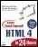 Book : XML Bible Author : Winston Publication : Wiely $ 40.5  ECE  EEE CIVIL Book :AI Author : S.Russel Publication : Princeton hall $ 63  Book : Java 2 Author : Watson Publication : BPB publications $ 35.5  Book : HTML in 24 hours Author : Sam Peter Publication : Sam publication $ 50
4 | CART PAGE:  The cart page contains the details about the books which are added to the cart. The cart page should look like this:  Logo Web Site Name  Home Login Registration Catalogue Cart  CSE Book name Price Quantity Amount  ECE Java 2 $35.5 2 $70  EEE XML bible $40.5 1 $40.5  CIVIL Total amount - $130.5
5 | REGISTRATION PAGE:  Create a “registration form “with the following fields  1) Name (Text field) 2) Password (password field)  - E-mail id (text field)  - Phone number (text field)  - Sex (radio button)  - Date of birth (3 select boxes)  - Languages known (check boxes – English, Telugu, Hindi, Tamil)  - Address (text area)
6 | Js VALIDATION: Write JavaScript to validate the following fields of the above registration page.  - Name (Name should contains alphabets and the length should not be less than 6 characters).  - Password (Password should not be less than 6 characters length).
7 | Js VALIDATION:  - E-mail id (should not contain any invalid and must follow the standard pattern (name@domain.com)  - Phone number (Phone number should contain 10 digits only).
8 | CSS : Design a web page using CSS (Cascading Style Sheets) which includes the following:  - Use different font, styles:  In the style definition you define how each selector should work (font, color etc.). Then, in the body of your pages, you refer to these selectors to activate the styles.  - Set a background image for both the page and single elements on the page.
9 | CSS :  - Control the repetition of the image with the background-repeat property.  As background-repeat: repeat Tiles the image until the entire page is filled, just like an ordinary background image in plain HTML.  - Define styles for links as  A:link  A:visited  A:active  A:hover
10 | Consider a small topic of your choice on which you can develop static web pages and try to implement all topics of html,CSS, and Js within the topic  Choose any topic:  - Your own portfolio  - To –Do List  - Survey Form  - A Tribute Page  - A Questionnaire

STUDY AND EVALUATION SCHEME

Course  Code | Course  Name | Teaching Scheme |  |  |  | Credits Assigned
BCS-353 (P) |  | Theory | Practical | Tutorial |  | Theory |  | Practical |  | Tutorial |  | Total
 | Web Designing | 00 | 02  (50) |  | 00 |  | 00 |  | 01 |  | 00 |  | 01
 | Workshop |  | Marks)


IMS Engineering College
NH-09, Adhyatmik Nagar, Near Dasna, Distt. Ghaziabad, U.P.
Tel: (0120) 4940000
Department of Computer Science and Engineering

Course Name: Web Designing Lab Course Code: BCS-353
Semester / Year: 3^{th /}2rd NBA Code: C 221

COURSE OUTCOMES |  | Bloom’s Level
C221.1 | Describe the concepts of HTML and design static Web pages. | K2,K6
C221.2 | Explain the concepts of CSS and design Web pages. | K2
C221.3 | Identify the concept of HTML, CSS, and JavaScript framework for developing responsive, mobile-first websites | K1,K2
C221.4 | Gain knowledge on client side scripting (Java Script) and develop a web page using Js Validation. | K3
C221.5 | Develop and implement website using HTML, CSS, Java Script | K6

CO-PO Mapping
Course Outcome | PO 1 | PO2 | PO3 | PO4 | PO5 | PO6 | PO7 | PO8 | PO9 | PO10 | PO11 | PO12 | PSO1 | PSO2
C221.1 | 3 | 2 | 3 | 2 | 3 | - | - | 1 | 2 | 1 | 2 | 3 | 3 | 3
C221.2 | 3 | 2 | 3 | 2 | 3 | - | - | 1 | 2 | 1 | 2 | 3 | 3 | 3
C221.3 | 3 | 3 | 3 | 2 | 3 | - | - | 1 | 2 | 1 | 2 | 3 | 3 | 3
C221.4 | 3 | 3 | 3 | 2 | 3 | - | - | 1 | 2 | 1 | 2 | 3 | 3 | 3
C221.5 | 3 | 3 | 3 | 2 | 3 | - | - | 1 | 2 | 1 | 2 | 3 | 3 | 3
C221 | 3 | 2.6 | 3 | 2 | 3 | - | - | 1 | 2 | 1 | 2 | 3 | 3 | 3

LIST OF PROGRAMS

Subject: Web Designing Lab Code: BCS-353

List of Experiments
S.no | List of Experiments(Indicative and not limited to ) | MAPPING  WITH CO
1 | Design the following static web pages required for an online book store web site.  HOME PAGE:  - The static home page must contain three frames.  - Top frame: Logo and the college name and links to Home page, Login page, Registration page, Catalogue page and Cart page (the description of these pages will be given below).  Left frame: At least four links for navigation, which will display the catalogue of respective links.  For e.g.: When you click the link “CSE” the catalogue for CSE Books should be displayed in the Right frame. Right frame: The pages to the links in the left frame must be loaded here. Initially this page contains description of the web site.  Logo Web Site Name  Home Login Registration Catalogue Cart  CSE ECE EEE CIVIL Description of the Web Site | C221.1
2 | Logo Web Site Name  Home Login Registration Catalogue Cart  CSE ECE EEE CIVIL Login Page User Name: Passwords: Reset Submit | C221.1
3 | CATALOGUE PAGE:  The catalogue page should contain the details of all the books available in the web site in a table. The details should contain the following:  - Snap shot of Cover Page.  - Author Name.  - Publisher.  - Price.  - Add to cart button.  Logo Web Site Name  Home Login Registration Catalogue Cart  CSE  Book : XML Bible Author : Winston Publication : Wiely $ 40.5  ECE  EEE CIVIL Book : AI Author : S.Russel Publication : Princeton hall $ 63  Book : Java 2 Author : Watson Publication : BPB publications $ 35.5  Book : HTML in 24 hours Author : Sam Peter Publication : Sam publication $ 50 | C221.1
4 | CART PAGE:  The cart page contains the details about the books which are added to the cart. The cart page should look like this:  Logo Web Site Name  Home Login Registration Catalogue Cart  CSE Book name Price Quantity Amount  ECE Java 2 $35.5 2 $70  EEE XML bible $40.5 1 $40.5  CIVIL Total amount - $130.5 | C221.1
5 | REGISTRATION PAGE:  Create a “registration form “with the following fields  - Name (Text field) 2) Password (password field)  - E-mail id (text field)  - Phone number (text field)  - Sex (radio button)  - Date of birth (3 select boxes)  - Languages known (check boxes – English, Telugu, Hindi, Tamil)  - Address (text area) | C221.1
6 | Js VALIDATION: Write JavaScript to validate the following fields of the above registration page.  - Name (Name should contains alphabets and the length should not be less than 6 characters).  - Password (Password should not be less than 6 characters length). | C221.3
7 | Js VALIDATION:  - E-mail id (should not contain any invalid and must follow the standard pattern (name@domain.com)  - Phone number (Phone number should contain 10 digits only). | C221.4
8 | CSS : Design a web page using CSS (Cascading Style Sheets) which includes the following:  - Use different font, styles:  In the style definition you define how each selector should work (font, color etc.). Then, in the body of your pages, you refer to these selectors to activate the styles.  - Set a background image for both the page and single elements on the page. | C221.2
9 | CSS :  - Control the repetition of the image with the background-repeat property.  As background-repeat: repeat Tiles the image until the entire page is filled, just like an ordinary background image in plain HTML.  - Define styles for links as  A:link  A:visited  A:active  A:hover | C221.2
10 | Consider a small topic of your choice on which you can develop static web pages and try to implement all topics of html, CSS, and Js within the topic  Choose any topic:  - Your own portfolio  - To –Do List  - Survey Form  - A Tribute Page  - A Questionnaire | C221.5

EXPERIMENT NO. - 1

Design the following static web pages required for an online book store website.

Design the following static web pages required for an online book store web site.
HOME PAGE:
- The static home page must contain three frames.
- Top frame: Logo and the college name and links to Home page, Login page, Registration page, Catalogue page and Cart page (the description of these pages will be given below).
Left frame: At least four links for navigation, which will display the catalogue of respective links.
For e.g.: When you click the link “CSE” the catalogue for CSE Books should be displayed in the Right frame. Right frame: The pages to the links in the left frame must be loaded here. Initially this page contains description of the web site.

Logo | Web Site Name
Home | Login | Registration | Catalogue | Cart
CSE ECE EEE  CIVIL | Description of the Web Site

home. html
<html>
<head>
<title>IMS ENGINEERING COLLEGE</title>
</head>
<frameset cols="25%,75%">
<frameset rows="25%,10%,65%">
<frame name ="f11" src="D:\Vaishali\2025-26\WD LAB\vaishali\logo.html" >
<frame name ="f21" src=" D:\Vaishali\2025-26\WD LAB\vaishali\home1.html">
<frame name ="f31 "src=" D:\Vaishali\2025-26\WD LAB\vaishali\courses1.html">
</frameset>

<frameset rows="25%,10%,65%">

<frame name ="f12"src=" D:\Vaishali\2025-26\WD LAB\vaishali\name.html">
<frameset cols="18%,18%,18%,18%">
<frame name ="f22" src=" D:\Vaishali\2025-26\WD LAB\vaishali\login1.html">
<frame name ="f23" src=" D:\Vaishali\2025-26\WD LAB\vaishali\registration.html">
<frame name ="f24" src=" D:\Vaishali\2025-26\WD LAB\vaishali\catalogue1.html">
<frame name = "f25" src=" D:\Vaishali\2025-26\WD LAB\vaishali\cart1.html" >
</frameset>
<frame name = "f32" src=" D:\Vaishali\2025-26\WD LAB\vaishali\home2.html">
</frameset>
</frameset>
</html>
Logo.html
<html>
<head>
<title>LOGO</title>
</head>
<body bgcolor="#ffcc00">
<img src="D:\Vaishali\2025-26\WD LAB\vaishali\images.jpg" height="100%" width=100%>
</body>
</html>
home1.html
<html>
<head>
<title>HOME1</title>
</head>
<body bgcolor="#ffcc99">
<a href="home.html"> HOME </a>
</body>
</html>
courses1.html
<html>
<head>
<title>home1</title>
</head>
<ul type="none">
<li ><a href="CSE.html" target="f32">CSE </a><br><br>
<li ><a href="ECE.html" target="f32" >ECE </a><br><br>
<li ><a href="EEE.html" target="f32" >EEE </a><br><br>
<li ><a href="CIVIL.html" target="f32" ">CIVIL </a>
</ul>
</html>

name.html

<html>

<head>

<title>home1</title>

</head>

<body bgcolor="#ffcc66">

<div align="Center"> IMS Engineering College,Ghaziabad </div>

</body>

</html>

login1.html
<html>
<head>
<title>home1</title>
</head>
<body bgcolor="#ffcc99">

<a href="login.html" target="f32">Login </a>
</body>

</html>

registration .html

<html>
<head>
<title>home1</title>
</head>
<body bgcolor="#ffcc99">
<a href="registration.html" target="f32">Registration </a>

</body>
</html>
catalogue1.html

<html>
<head>
<title>home1</title>
</head>
<body bgcolor="#ffcc99">

<a href="catalogue.html" target="f32">Catalogue</a>

</body>
</html>

cart.html

<html>
<head>
<title>home1</title>
</head>
<body bgcolor="#ffcc99">
<a href="cart.html" target="f32">Cart </a>

</body>
</html>

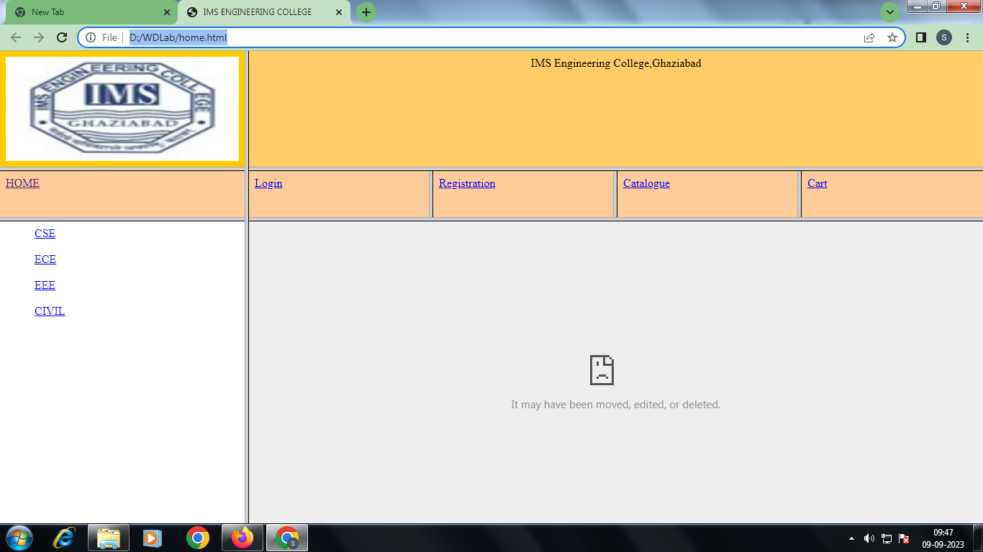

CSE.html
<html>
<head>
<title>home1</title>
</head>
<body>
<h1><div align = "Center">Department of Computer Science & Engineering </div> </h1>
<p align="justify">

The Department of Computer Science & Engineering, established in the year 2002 with current intake of 240 students, imparts quality education and believes in creating new opportunities for students to meet the challenges of Technological development in Computer Science & Engineering. The B. Tech. (CSE) program is affiliated with Dr. APJ Abdul Kalam Technical University, Lucknow, and is approved by AICTE, New Delhi.

The Department has qualified faculty members, infrastructure, and state-of-the-art equipment which help in providing an excellent environment for teaching and learning. The department is actively involved in Industrial Training, Project Development and other professional activities. Department of Computer Science and Engineering has signed various MOUs with highly recognized organizations to provide live projects and Internship opportunities to our Engineering Students. Industrial visits, Workshops, Seminars, Conferences, and Mini Projects for students are also conducted regularly to encourage students. The major employers of our students are well-renowned Indian conglomerates like TCS, Infosys, Wipro, HCL, and other multinational companies including IBM, Accenture & HP.
</p>
</body>
</html>

ECE.html
<html>
<head>
<title>home1</title>
</head>
<body>

<h1><div align = "Center">Department of Electronics and Communication Engineering </div> </h1>
<p align="justify">

Electronics and Communications Engineering (ECE) involves researching, designing, developing and testing of electronic equipment used in various systems. Electronics and Communications engineers also conceptualize and oversee the manufacturing of communications and broadcast systems. This stream of engineering deals with analog transmission, basic electronics, microprocessors, solid state devices, digital & analog communication, analog integrated circuits,
microwave engineering, satellite communication, antenna and wave propagation. It also deals with the manufacturing of electronic devices, circuits, and communications equipment. This branch of engineering also plays a vital role ensuring fastest means of communication across the world.

</body>
</html>

EEE.html

<html>
<head>
<title>home1</title>
</head>
<body>
<h1><div align = "Center">Department of Electrical and Electronics Engineering </div> </h1>
<p align="justify">
The Department of Electrical and Electronics Engineering was established in year 2004 with aim to prepare students for a successful professional career in respective field. Historically, the field of Electrical & Electronics Engineering is one of the most versatile and has broad applications in multidisciplinary sectors. The Department has focused towards integrating academics with cutting edge technologies in modern world.

</body>
</html>

CIVIL.html

<html>
<head>
<title>home1</title>
</head>
<body>

<h1><div align = "Center">Department of Civil Engineering </div> </h1>
<p align="justify">

Civil engineering is the professional practice of designing and developing infrastructure projects. This can be on a huge scale, such as the development of nationwide transport systems or water supply networks, or on a smaller scale, such as the development of individual roads or buildings.
</p>
</body>
</html

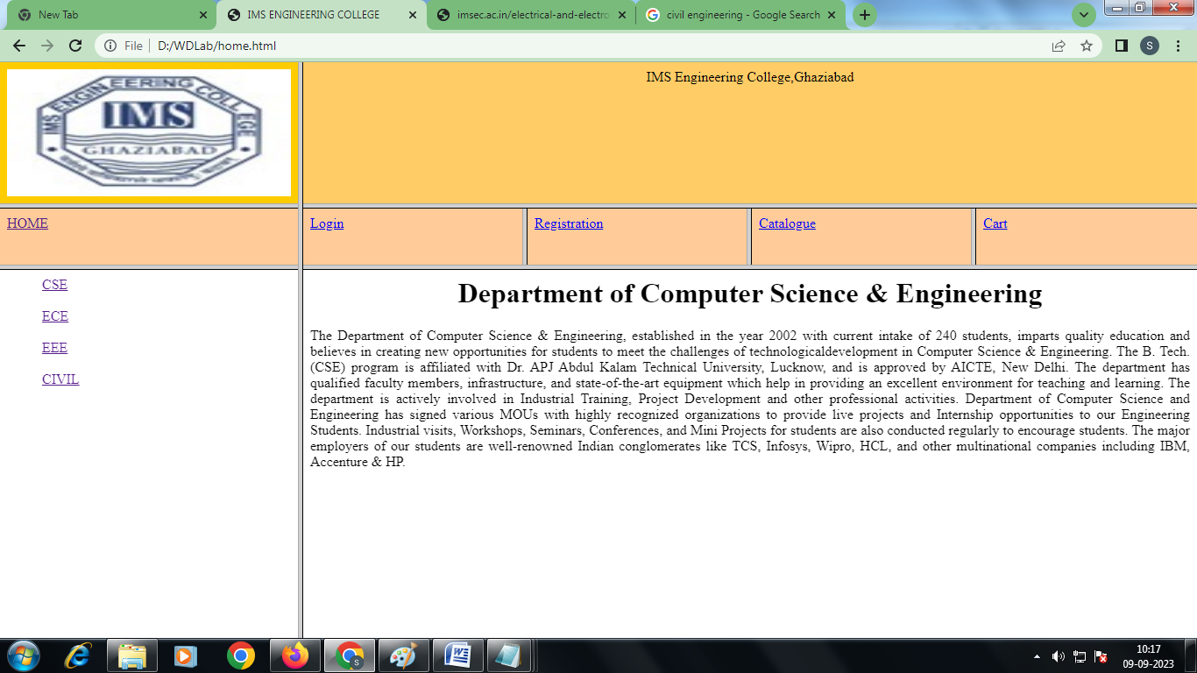

Viva Questions

  - What is HTML?
  - Difference between HTML and XHTML
  - Differentiate between HTML & DHTML.
Q4. Explain Radio Button. Differentiate Radio Button & Check Box.
Q.5 Define the drop down list.

EXPERIMENT-2
- LOGIN PAGE: Login page must contain Login field, Password field, Submit and reset buttons.
Logo | Web Site Name
Home | Login | Registration | Catalogue | Cart
CSE  ECE  EEE  CIVIL | Login Page  User Name:  Password Passwords:  Submit  Reset

login.html

<html>
<head>
<title>home1</title>
</head>
<body>
<form name="login">
<Center>
<h3> <u> Login Page </u> </h3>
username: <input type="text" name="uname" ><br>
password: <input type="password" name="pwd" ><br>
<input type="submit" value="Submit" >
<input type="reset" value="reset">
</center>
</form>
</body>
</html>

OUTPUT:
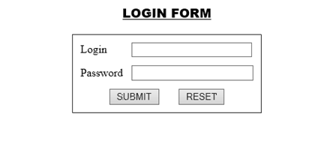

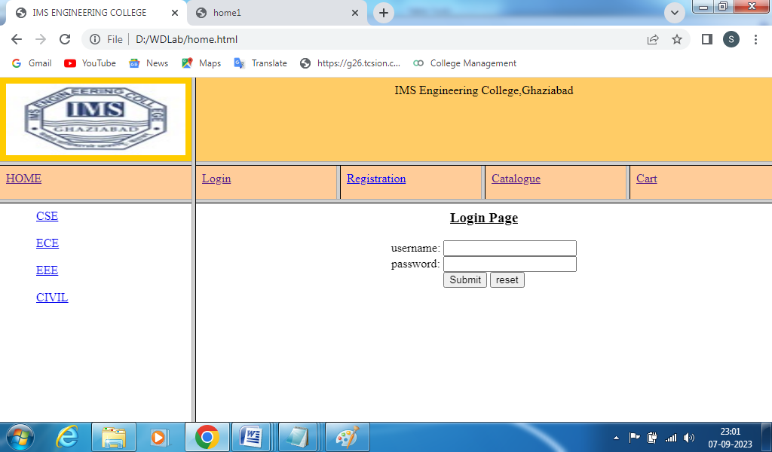

Viva Questions

  - What is CSS?
  - Explain the different types of css.
  - Explain the external file in css.
  - Q4. Explain frameset element in html.
Q.5 Define table tag. Explain Row space and Column space in table tag.

EXPERTMENT-3
CATOLOGUE PAGE:
The catalogue page should contain the details of all the books available in the web site in a table. The details should contain the following:
- Snap shot of Cover Page.
- Author Name.
- Publisher.
- Price.
- Add to cart button.

Logo | Web Site Name
Home | Login | Registration | Catalogue | Cart
CSE |  | Book : XML Bible Author : Winston  Publication : Wiely | $ 40.5
ECE
EEE  CIVIL |  | Book : AI  Author : S.Russel  Publication : Princeton hall | $ 63
 |  | Book : Java 2 Author : Watson  Publication : BPB publications | $ 35.5
 |  | Book : HTML in 24 hours Author : Sam Peter Publication : Sam publication | $ 50

catalogue.html

<html>

<head>

<title>catalouge</title>

</head>

<body>

<center>

<table border=2 cellpadding=10 cellspacing=10>

<tr>

<td> <img src="D:\WDLab\cat1.jpg" height=100 width=100></td>

<td>Book:XML Bible<br> Author:Wingston<br> Publication:wiely</td>

<td>$40.5</td>

<td><input type="button"value="add to cart"></td>

</tr>

<tr>

<td> <img src ="D:\WDLab\cat2.jpg" height=100 width=100></td>

<td>Book:A1<br> Author:S.Rusell<br> Publication:Princeton hall</td>

<td>$63</td>

<td><input type="button"value="add to cart"></td>

</tr>

<tr>

<td> <img src="D:\WDLab\cat3.jpg" height=100 width=100></td>

<td>Book:JAVA 2<br> Author:Watson<br> Publication:BPB</td>

<td>$35.5</td>

<td><input type="button"value="add to cart"></td>

</tr>

<tr>

<td> <img src="D:\WDLab\cat4.jpg" height=100 width=100></td>

<td>Book:Html in 24 hrs<br> Author:Sam Peter<br> Publication:SAM</td>

<td>$50</td>

<td><input type="button"value="add to cart"></td>

</tr>

</table>

</center>

</body>

</html>

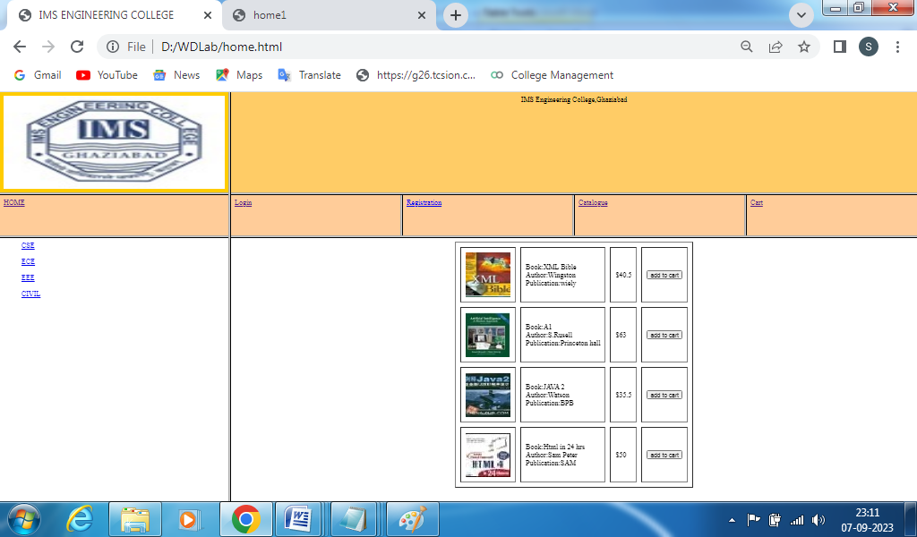

Viva Questions
  - What is JavaScript?
  - Explain the types of java script.
  - Explain the external JavaScript file.
Q4. How to check form validation on front end.
Q.5 How to import image tag in html.

EXPERIMENT NO. – 4

CART PAGE:
The cart page contains the details about the books which are added to the cart. The cart page should look like this:
Logo | Web Site Name
Home | Login | Registration |  | Catalogue | Cart
CSE | Book name Price |  | Quantity | Amount
ECE | Java 2 $35.5 |  | 2 | $70
EEE | XML bible $40.5 |  | 1 | $40.5
CIVIL | Total amount - $130.5

<html>
<body >
<table cellspacing="50" cellpadding="20">
<tr> <td>Book name</td>
<td>price</td>

<td>quantity</td>
<td>amount</td>
</tr>
<tr>
<td>java2</td>
<td>$35.5</td>
<td>2</td>
<td>$70</td>
</tr>
<tr>
<td>XML bible</td>
<td>$40.5</td>
<td>1</td>
<td>$40.5</td>
</tr>
<tr>
<td></td> <td>
</td>
<td>Total amount </td>
<td>130.5 </td>
</tr>
</body>
</html>

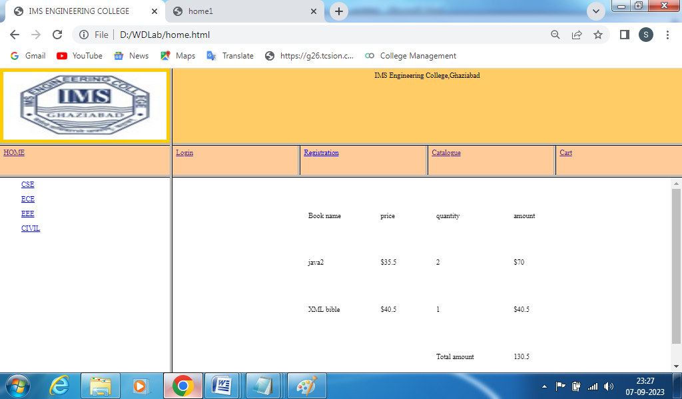

Viva Questions
  - Describe Client side Scripting language?
  - What is the Box model in CSS? Which CSS properties are parts of it?
  - What are the limitations of CSS?
Q4. What are the different types of Selectors in CSS?
Q.5 What are the advantages of using CSS?

EXPERIMENT-5

REGISTRATION PAGE:
- Create a “registration form “with the following fields
- Name (Text field) 2) Password (password field)
- E-mail id (text field)
- Phone number (text field)
- Sex (radio button)
- Date of birth (3 select boxes)
- Languages known (check boxes – English, Telugu, Hindi, Tamil)
- Address (text area)

<html>
<head>
<title>Registration Page</title>
</head>
<body>
<center>
<h3 align="center"><u>REGISTRATION PAGE</u></h3>
<table border="3">
<tr><td>
<form name="f1" action="" method="post" onsubmit="">
<table cellspacing="10" cellpadding="5">
<tr><td>NAME</td><td><input type="text" size="30" name="uname"/></td></tr>
<tr><td>PASSWORD</td><td><input type="password" size="30" name="pass"/></td></tr>
<tr><td>E-MAIL ID</td><td><input type="text" size="30" name="email"/></td></tr>
<tr><td> PHONE NUMBER</td><td><input type="text" size="15" name="phone"/></td></tr>
<tr><td>GENDER</td><td><input type="radio" name="gen" value="m" />MALE
<input type="radio" name="gen" value="f" />FEMALE </td></tr>
<tr><td>DATE OF BIRTH</td>
<td><select name="day">
<option value="day">DAY</option>
<option value="1">1</option>
<option value="2">2</option>
<option value="3">3</option>
<option value="4">4</option>
<option value="5">5</option>
<option value="6">6</option>
<option value="7">7</option>
<option value="8">8</option>
<option value="9">9</option>
<option value="10">10</option>
<option value="11">11</option>
<option value="12">12</option>
<option value="13">13</option>
<option value="14">14</option>
<option value="15">15</option>
<option value="16">16</option>
<option value="17">17</option>
<option value="18">18</option>
<option value="19">19</option>
<option value="20">20</option>
<option value="21">21</option>
<option value="22">22</option>
<option value="23">23</option>
<option value="24">24</option>
<option value="25">25</option>
<option value="26">26</option>
<option value="27">27</option>
<option value="28">28</option>
<option value="29">29</option>
<option value="30">30</option>
<option value="31">31</option>
</select>
<select name="month">
<option value="month">MONTH</option>
<option value="jan">JANUARY</option>
<option value="feb">FEBRUARY</option>
<option value="mar">MARCH</option>
<option value="apr">APRIL</option>
<option value="may">MAY</option>
<option value="jun">JUNE</option>
<option value="jul">JULY</option>
<option value="aug">AUGUST</option>
<option value="sep">SEPTEMBER</option>
<option value="oct">OCTOBER</option>
<option value="nov">NOVEMBER</option>
<option value="dec">DECEMBER</option>
</select>
<select name="year">
<option value="year">YEAR</option>
<option value="1986">1986</option>
<option value="1987">1987</option>
<option value="1988">1988</option>
<option value="1989">1989</option>
<option value="1990">1990</option>
<option value="1991">1991</option>
<option value="1992">1992</option>
<option value="1993">1993</option>
<option value="1994">1994</option>
<option value="1995">1995</option>
<option value="1996">1996</option>
<option value="1997">1997</option>
<option value="1998">1998</option>
<option value="1999">1999</option>
<option value="2000">2000</option>
<option value="2001">2001</option>
<option value="2002">2002</option>
<option value="2003">2003</option>
<option value="2004">2004</option>
<option value="2005">2005</option>
<option value="2006">2006</option>
<option value="2007">2007</option>
<option value="2008">2008</option>
<option value="2009">2009</option>
<option value="2010">2010</option>
<option value="2011">1980</option>
<option value="2012">1981</option>
<option value="2013">1982</option>
<option value="2014">1983</option>
</select></td></tr>
<tr><td>LANGUAGES KNOWN</td>
<td>
<input type="checkbox" value="eng" name="lang" />ENGLISH
<input type="checkbox" value="tel" name="lang" />TELUGU
<input type="checkbox" value="hin" name="lang" />HINDI
<input type="checkbox" value="tam" name="lang" />TAMIL
</td></tr>
<tr>
<td>ADDRESS</td>
<td><textarea name="addr" cols="25" rows="5"></textarea></td></tr>
<tr><td colspan="2" align="center"><input type="submit" value="SUBMIT"/>
&nbsp;&nbsp;&nbsp;&nbsp;&nbsp;&nbsp;<input type="reset" value="RESET" /></td>
</tr>
</table>
</form>
</td></tr></table>
</center>
</body>
</html>

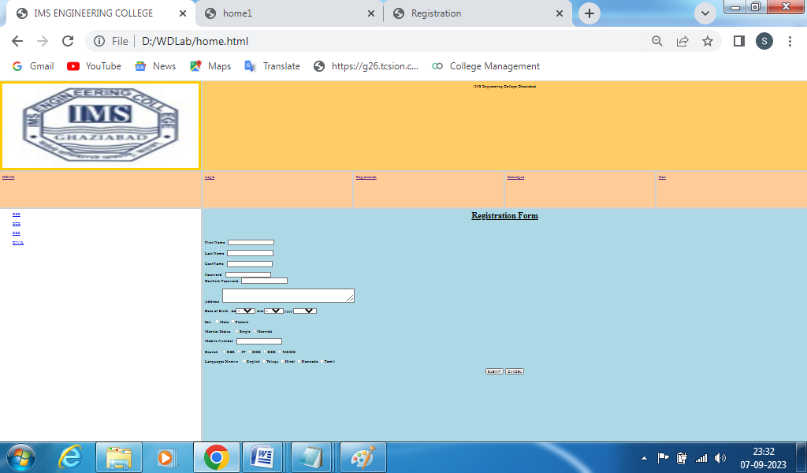

Viva Questions
  - what are tags and attributes in HTML?
  - what are different types of lists in HTML?
  - what are HTML Entities?
Q4. What is the difference between the ‘id’ attribute and the ‘class’ attribute of HTML elements?
Q.5 Describe HTML layout structure.

EXPERIMENT-6

Js VALIDATION: Write JavaScript to validate the following fields of the above registration page.
- Name (Name should contains alphabets and the length should not be less than 6 characters).
- Password (Password should not be less than 6 characters length).

<html>
<head>
<title>validating a textbox</title>
<script language="javascript">
function button_click()
{ var fname=f.fname.value; var spchar = "!@#$%^&*()+=-[]\\\';,./{}|\":<>?~";
var number="0123456789";
if(fname.length<6)
{
23
alert("first name atleast 6 characters");
}
if(fname!="")
{
for (var i=0;i<fname.length;i++)
{
if(spchar.indexOf(fname.charAt(i)) != -1)
{ alert ("Userid should not have special characters");
f.fname.value=" "; return false;
}
}
}
if(fname!="")
{
for (var i=0;i<fname.length;i++)
{
if(number.indexOf(fname.charAt(i)) != -1)
{
alert ("Userid should not have numbers");
f.fname.value=""; return false; }
}
if(fname.length>=6)
alert("valid username");
}
}
</script>
<body>
<center>
<form name="f">
<table>
<h2 align="center">USER NAME VALIDATION</h2>
<tr> <td align="right">USERNAME:</td>
<td><input type="text" name="fname" maxlength=20 size=30></td>
</tr> <br>
<tr>
<td></td>
<td><input type="button" value="SUBMIT" onClick="button_click()">
</td>
</tr>
</form>
</table>
</center>
</body>
</html>
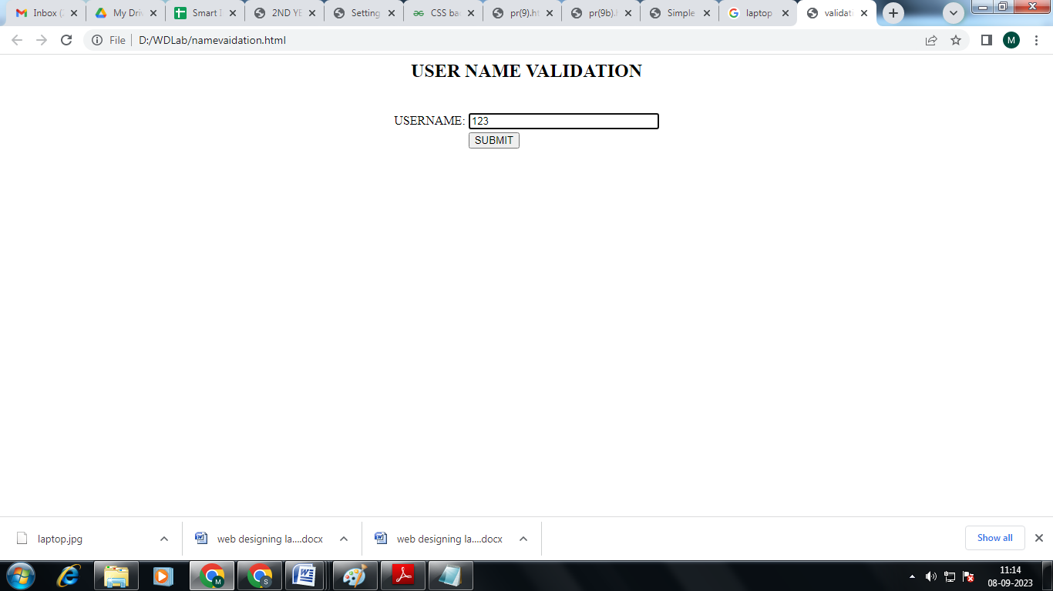

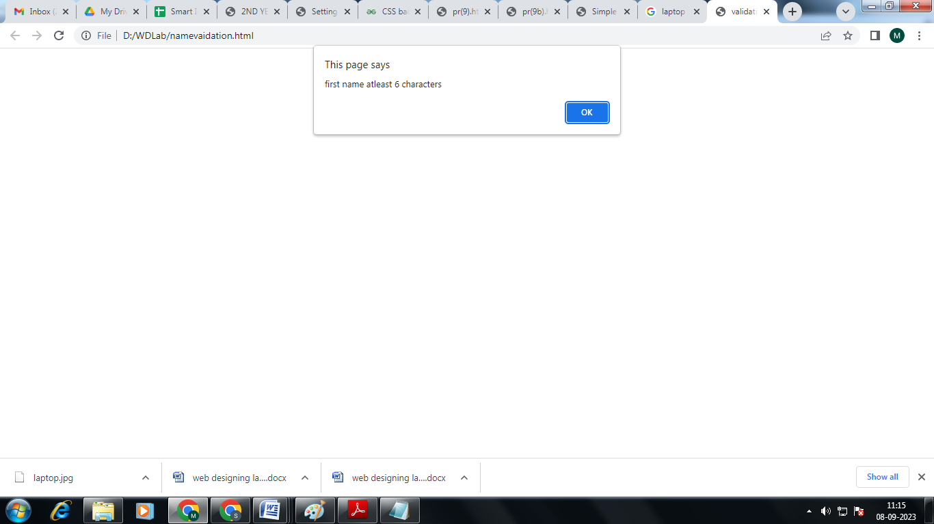

Password Validation

<html>
<head>
<title>PASSWORD VALIDATION</title>
<script language="javascript">
function pass()
{
var pw=f.pw.value;
var cpw=f.cpw.value;
if(pw.length<6)
{
alert("PASSWORD MUST BE 6 CHARACTERS"); } if(pw!=cpw
)
{
alert("PASSWORD DON'T MATCH");
}
else if(pw.length>=6)
alert("PASSWORD VALIDATION SUCCESS");
}
</script>
</head>
<body>
<form name="f">
<table align="center">
<h2 align="center">PASSWORD VALIDATION</h2>
<br>
<tr>
<td align="right">PassWord:</td>
<td align="left"><input type="PassWord" maxlength="10" size="30"name="pw"></td>
</tr>
<tr>
<td align="right">Confirm PassWord:</td>
<td align="left"><input type="PassWord" maxlength="10" size="30"name="cpw"></td>
</tr>
<tr> <td></td>
<td><input type="button" value="SUBMIT" onClick="pass()"/></td>
</tr>
</table>
</form>
</body>
</html>

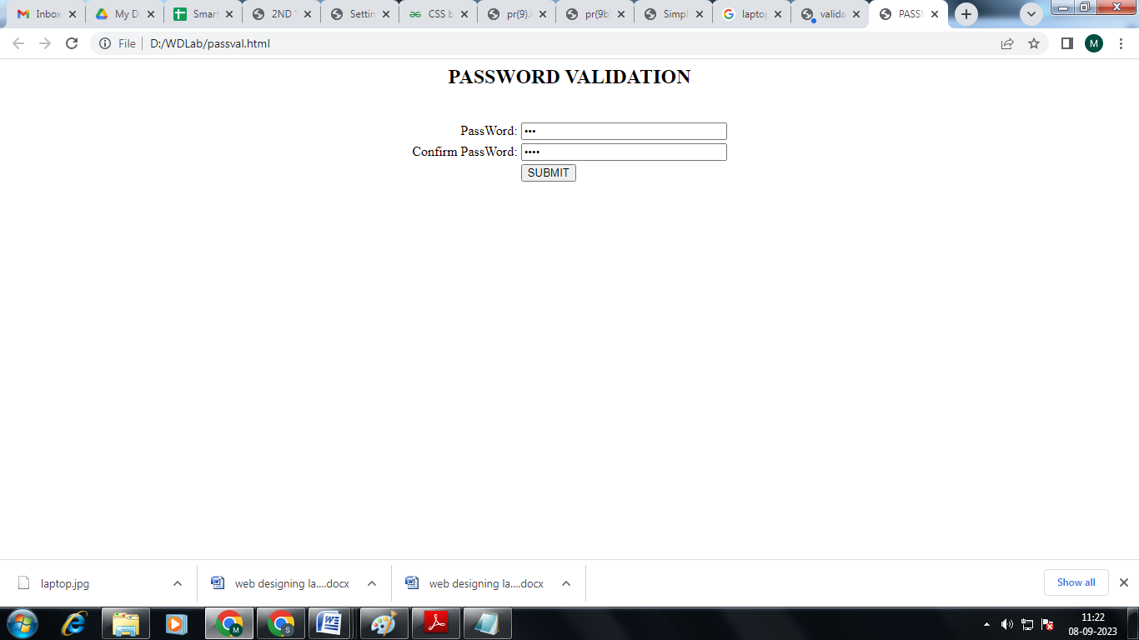

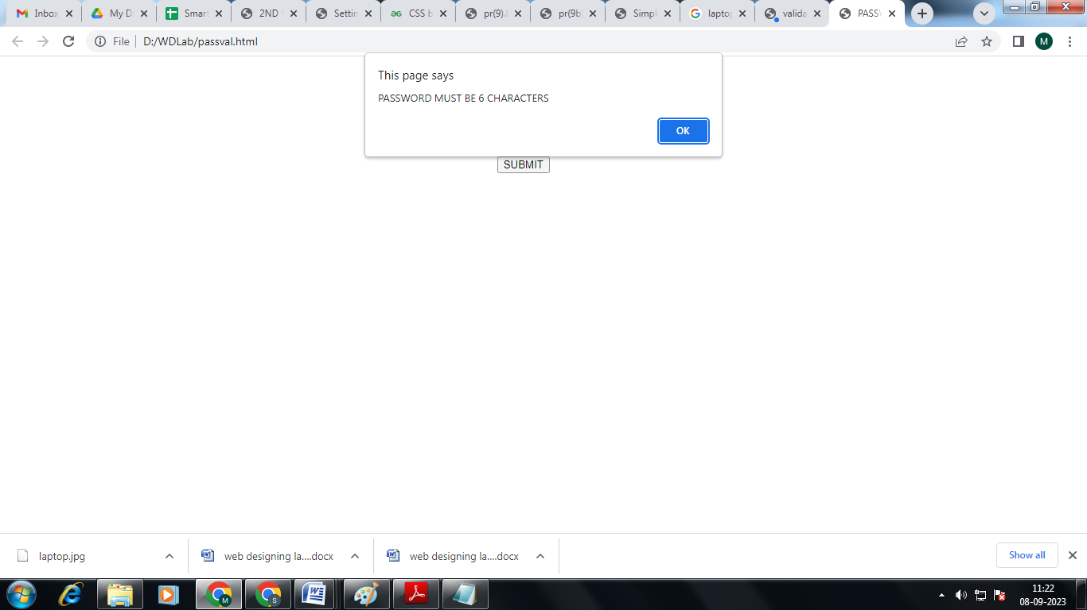

Viva Questions
  - What are the various formatting tags in HTML?
  - Explain how to indicate the character set being used by a document in HTML?
  - Which symbol is used for comments in JavaScript?
  - What would be the result of 3+2+”7″?
Q.5 What is the use of the isNaN function?

EXPERIMENT-7

Js VALIDATION:
- E-mail id (should not contain any invalid and must follow the standard pattern (name@domain.com)
- Phone number (Phone number should contain 10 digits only).

Email id Validation
<html>
<head>
<title>EMAIL ID VALIDATION</title>
<script language="javascript"> function check()
{
if(f.txtname.value.indexOf('@')==-1)
{
alert("invalid");
}
else if((f.txtname.value.indexOf('@')==0)||(f.txtname.value.indexOf('.')==0)||(f.txtname.value.indexOf('@'))>
(f.txtname.value.indexOf('.')))
{
alert("invalid email id");
f.txtname.value="";
}
else alert("valid email id");
}
</script>
</head>
<body>
<form name="f">
<table align="center">
<h2 align="center">EMAIL VALIDATION</h2>
<br>
<tr>
<td align="right">Email-ID:</td>
<td align="left"><input type="text" name="txtname" size=40> </tr>
<tr> <td></td>
<td><input type="button" value="SUBMIT" onClick="check()"/>
</td>
</tr>
</table>
</form>
</body>
</html>
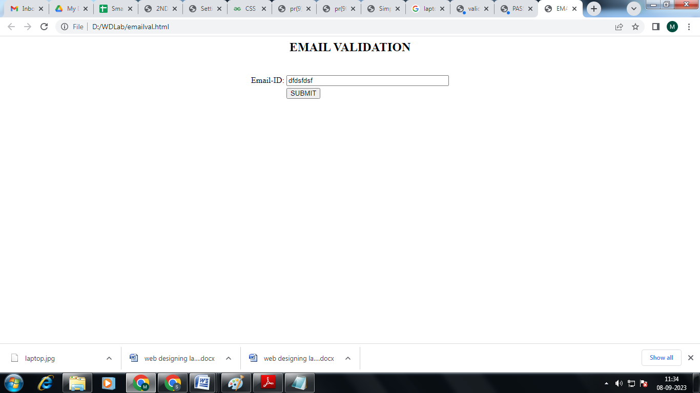

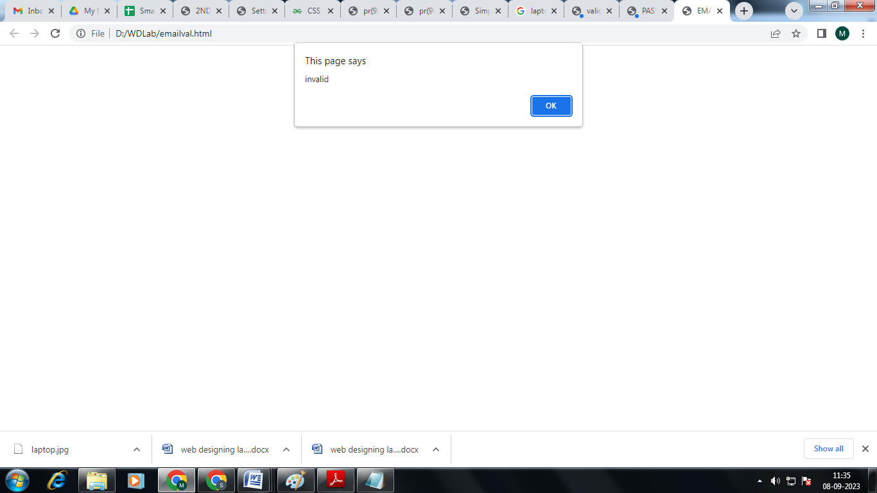

Mobile Number Validation

<html>
<head>
<title>PHONE NUMBER VALIDATION</title>
<script language="javascript">
function phno()
{ var ph=f.ph.value; if(ph.length==10)
{
if(isNaN(ph))
alert("It is not a valid Phone number");
else alert("It is a valid Phone number");
}
else
alert("Please enter a valid phone number");
}
</script>
</head>
<body>
<form name="f">
<table align="center"> <br><br><br><br>
<h2 align="center">PHONE NUMBER VALIDATION</h2> 3
<br>
<tr> <td align="right">PHONE NO:</td>
<td align="left"><input type="text" maxlength="15" size="30"name="ph"></td>
</tr>
<tr> <td></td>
<td><input type="button" value="SUBMIT" onClick="phno()"/>
</td>
</tr>
</table>
</form>
</body>
</html>

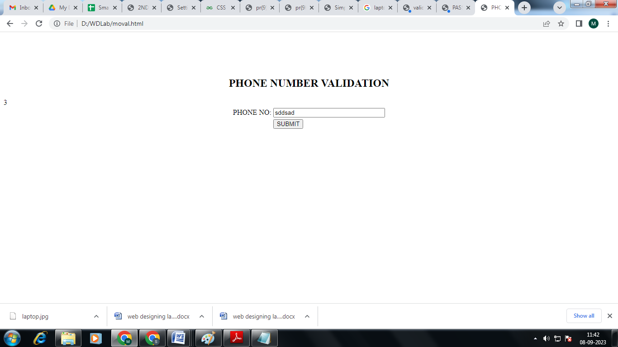

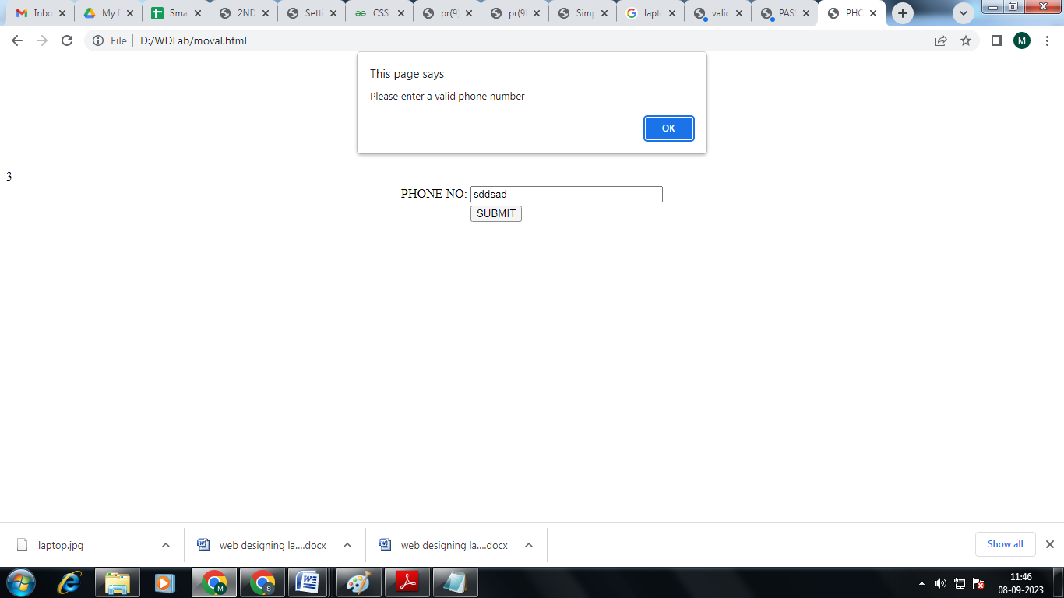

Viva Questions
  - Is it possible to break JavaScript Code into several lines?
  - What are undeclared and undefined variables?
  - What do you mean by NULL in JavaScript? Q4 What is a prompt box?
Q.5 What is the ‘this’ keyword in JavaScript?

Experiment-8

CSS : Design a web page using CSS (Cascading Style Sheets) which includes the following:
- Use different font, styles:
In the style definition you define how each selector should work (font, color etc.). Then, in the body of your pages, you refer to these selectors to activate the styles.
- Set a background image for both the page and single elements on the page.

styles.css
h1
{
color:red;
font-family:caStellar;
font-size:22pt;
text-decoration:underline;
}
h2
{
color:blue;
font-family:Chiller;
font-size:18pt;
text-decoration:overline;
}
p
{
color:magenta;
font-family:Trebuchet MS;
font-size:14pt;
font-style:italic;
}
fontstyles.html
<html>
<head>
<title>Usage of different font,styles and colors </title>
<link rel="stylesheet" type="text/css" href="styles.css"/>
</head>
<body>
<h1>This header is in red</h1>
<h2>This header is in blue</h2>
<p>This is normal text</p>
</body>
</html>
OUTPUT:

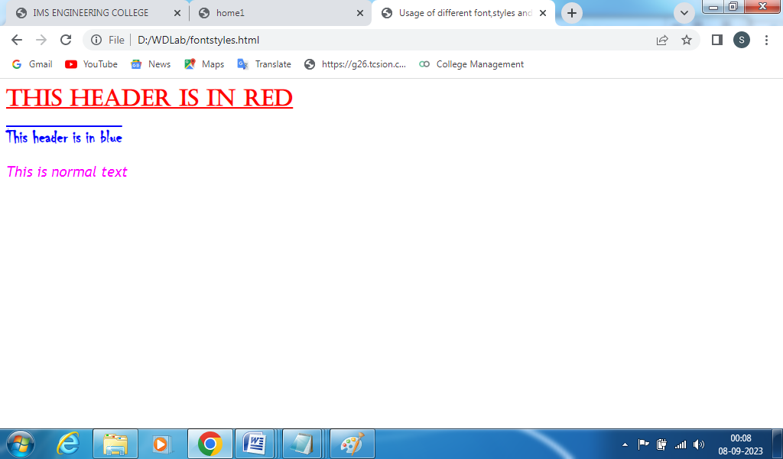

B. Set a background image for both the page and single elements on the page. bg_image.html

Life is beautiful!!!

<html>
<head>
<title>Setting background image</title>
<style type="text/css">
body
{
background-image:url("Tulips.jpg");
background-repeat: no-repeat;

}
</style>
</head>
<body text="#ee78a2">
<h1>Life is beautiful!!!</h1>
</body>
</html>

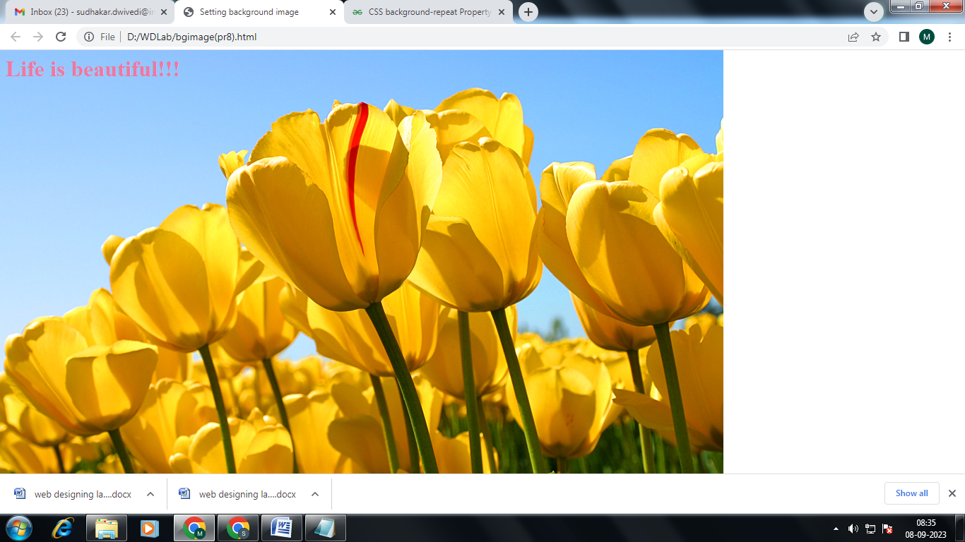

Viva Questions
  - What are the advantages of CSS?
  - What is Embedded Style Sheet?
  - What is the use of CSS Opacity?
  - Name the property for controlling the image repetition of the background.
  - What are the advantages of Internal Style Sheets?

EXPERIMENT-9

CSS :
- Control the repetition of the image with the background-repeat property.
As background-repeat: repeat Tiles the image until the entire page is filled, just like an ordinary background image in plain HTML.
- Define styles for links as
A:link
A:visited
A:active
A:hover

pr9(a).html
<html>
<head>
<style type="text/css">
body
{
background-image:url("cat1.jpg");
background-repeat:repeat }
</style>
</head>
<body>
<center>
<font color=fuchsia>
<h1>IMS ENGINEERING COLLEGE</h1>
</font>
</center>
</body>
</html>

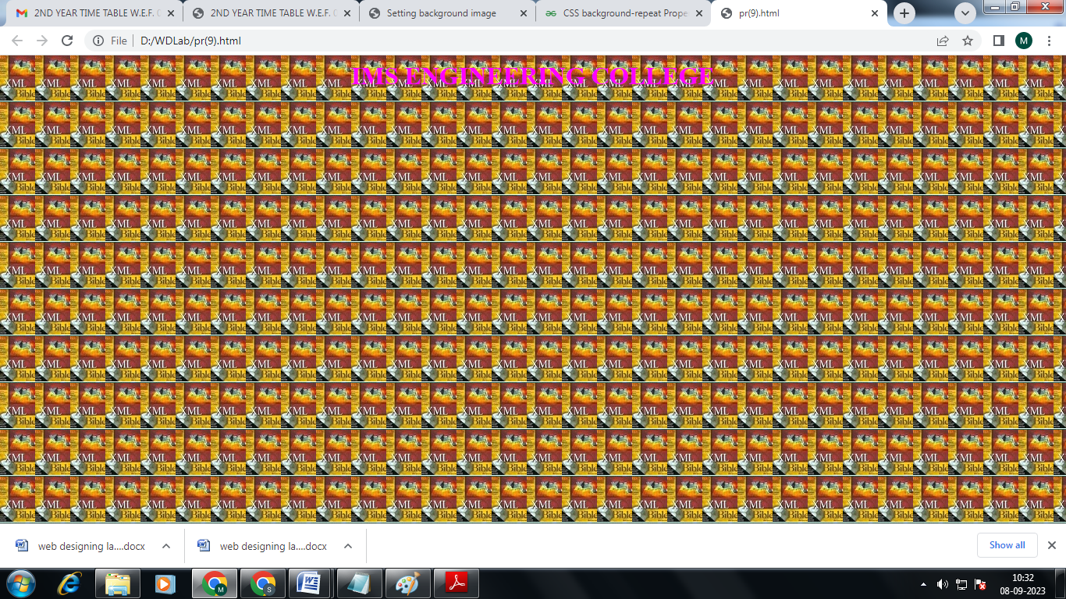

<html>
<head>
<style type="text/css">
a:link
{
color:blue;
}
a:hover{
background-color:green;
color:white;
}
a:visited{color:cyan;}
a:active
{
bacground-color:orange;
}</style></head>
<body background="hulk.gif" height="200" width="400">
<i><marquee> <h1>IMS ENGINEERING COLLEGE </h1> </marquee>
</i>
<a href="pr(9a).html">
<h2>Click Here !!!</h2>
</a>
</body>
</html>

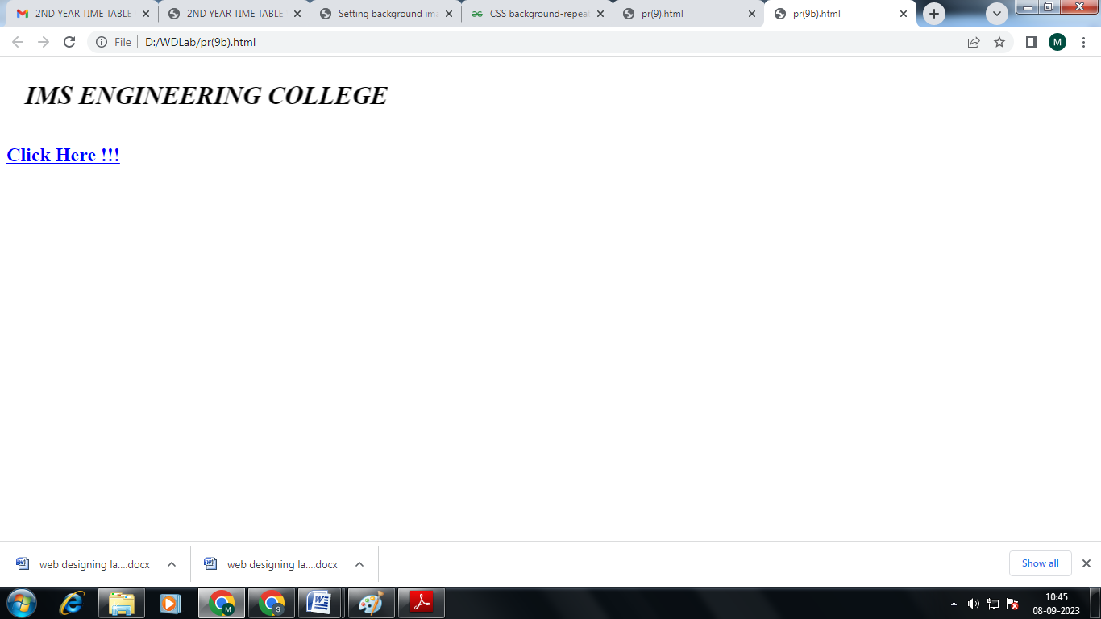

Viva Questions
  - What are the various markup languages available?
  - What is the difference between HTML and HTML 5?
  - What is! DOCTYPE?
  - What are the various heading tags and their importance?
  - What are attributes?

+

EXPERIMENT NO- 10

Consider a small topic of your choice on which you can develop static web pages and try to implement all topics of html,CSS, and Js within the topic
Choose any topic:
- Your own portfolio
- To –Do List
- Survey Form
- A Tribute Page

A Questionnaire
<!DOCTYPE html>

<html>

<head>
<title>
Simple web Development Template
</title>
</head>

<body>
<nav class="navbar background">
<ul class="nav-list">
<div class="logo">
<img src="logo.jpg">
</div>
<li><a href="#web">Web Technology</a></li>
<li><a href="#program">C Programming</a></li>
<li><a href="#course">Courses</a></li>
</ul>

<div class="rightNav">
<input type="text" name="search" id="search">
<button class="btn btn-sm">Search</button>
</div>
</nav>

<section class="firstsection">
<div class="box-main">
<div class="firstHalf">
<h1 class="text-big" id="web">
Web Technology
</h1>

<p class="text-small">
HTML stands for HyperText Markup
Language. It is used to design
web pages using a markup language.
HTML is the combination of Hypertext
and Markup language. Hypertext
defines the link between the web
pages. A markup language is used
to define the text document within
tag which defines the structure of
web pages. HTML is a markup language
that is used by the browser to
manipulate text, images, and other
content to display it in the required
format.
</p>

</div>
</div>
</section>

<section class="secondsection">
<div class="box-main">
<div class="secondHalf">
<h1 class="text-big" id="program">
C Programming
</h1>
<p class="text-small">
C is a procedural programming language.
It was initially developed by Dennis
Ritchie as a system programming
language to write operating system.
The main features of C language include
low-level access to memory, simple set
of keywords, and clean style, these
features make C language suitable for
system programming like operating system
or compiler development.
</p>

</div>
</div>
</section>

<section class="section">
<div class="paras">
<h1 class="sectionTag text-big">Java</h1>

<p class="sectionSubTag text-small">
Java has been one of the most
popular programming language
for many years. Java is Object
Oriented. However it is not
considered as pure object oriented
as it provides support for primitive
data types (like int, char, etc) The
Java codes are first compiled into byte
code (machine independent code). Then
the byte code is run on Java Virtual
Machine (JVM) regardless of the
underlying architecture.
</p>

</div>

<div class="thumbnail">
<img src="laptop.jpg" alt="laptop image">
</div>
</section>

<footer class="background">
<p class="text-footer">
Copyright ©-All rights are reserved
</p>

</footer>
</body>

</html>
Output:-
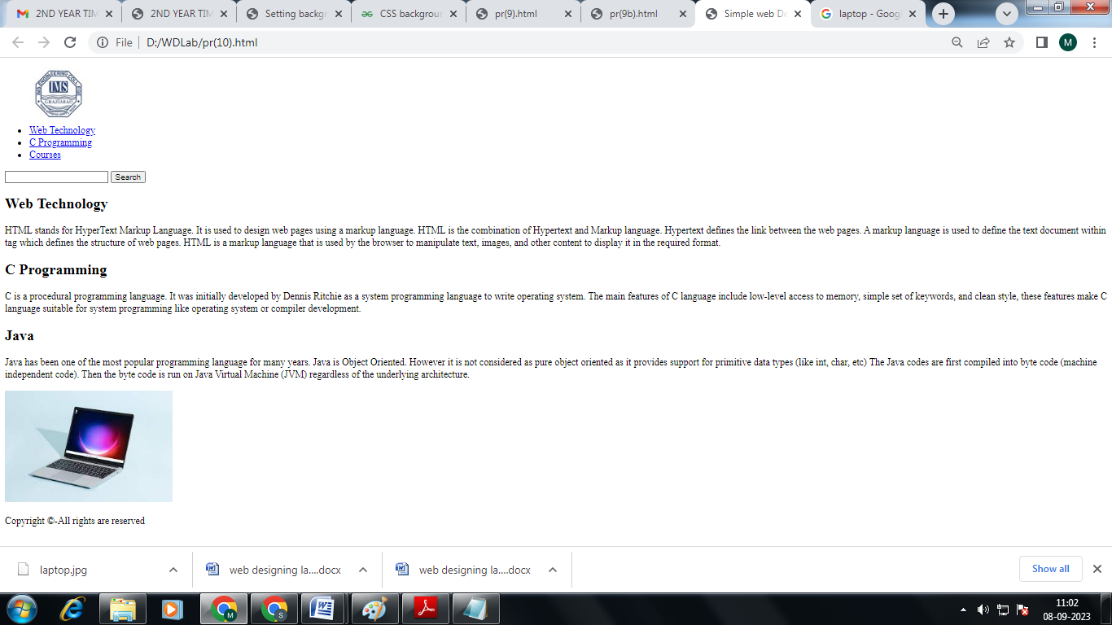

Viva Questions

  - How do you create an object in JavaScript?
  - How do you create an array in JavaScript?
  - What is Callback in JavaScript?
  - What are the ways of adding JavaScript code in an HTML file?
  - Define JavaScript functions & types of JavaScript.

